**Assessment :- SQL**

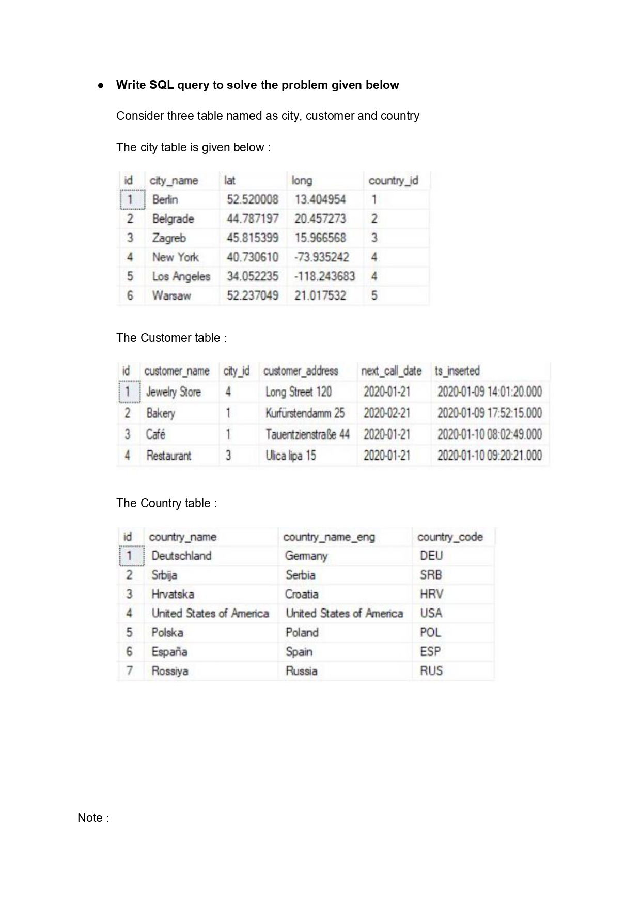

**Task : 1 (join multiple tables using left join)**

1. List all Countries and customers related to these countries:-

**Ans:-**

select Country.country_name,Customer.customer_name

from country

left join City on Country.id = City.country_id

left join Customer on City.id = Customer.city_id;

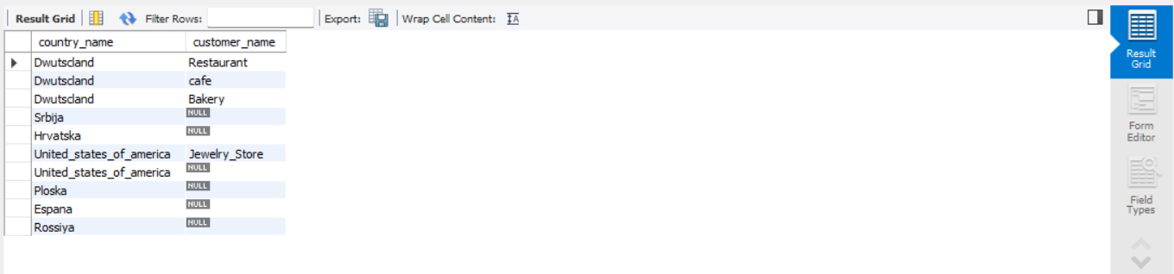

1. For each country displaying its name in English, the name of the city customer is located in as well as the name of the customer:-

**Ans:-**

select country.country_name_eng as

country_name_english,city.city_name,customer.customer_name

from country

left join city on city.country_id = country.id

left join customer on customer.city_id = city.id;

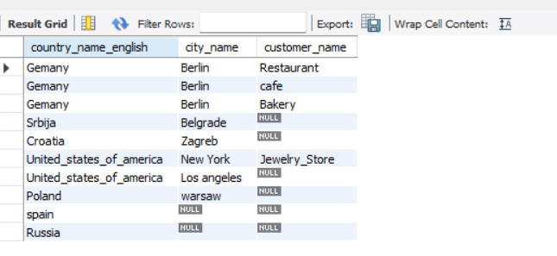

1. Return even countries without related cities and customers:-

ANS:-

select co.country_name,ci.city_name,cu.customer_name

from country co

left join city ci on co.id = ci.country_id

left join customer cu on ci.id = cu.city_id;

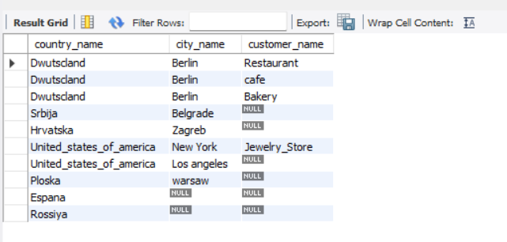

**Task : 2 (join multiple tables using both left and inner join)**

1. Return the list of all countries that have pairs(exclude countries which are not referenced by any city). For such pairs return all customers:-

**ANS:-**

select co.country_name,cu.customer_name

from country co

left join city ci on co.id = ci.country_id

left join customer cu on ci.id = cu.city_id;

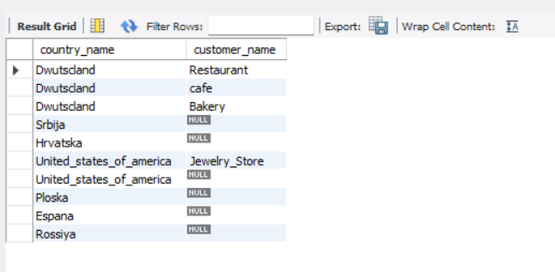

2.Return even pairs of not having a single customer :-

**ANS:-**

select country.country_name,country.country_code,city.city_name

from country

join city on country.id = city.country_id

left join customer on city.id = customer.city_id

where customer.id is null;

